**Introduction:**

As per the Project_66378:Smart_Energy_Customer_Master:

Source:SAP

Target:Hybris

Our Informatica Job is to Extract Data From Source and Transform Required Changes and Load to Target.

We have Developed as per the Team Requirement Below Workflows for:

1.Customer_Master_Address,

2. Customer_Master_SalesOrg,

3. Customer_Master_Partner,

4. Customer_Master_CMiR

These are the Workflow names in Informatica Power Center 10.4.1

|  |
| --- |
| wf_create_param_file_SME_SAP_HYBRIS |
| wf_acquire_SAP_HYBRIS_SME_CustomerMaster_ADDRESS |
| wf_acquire_SAP_HYBRIS_SME_CustomerMaster_SALESORG |
| wf_acquire_SAP_HYBRIS_SME_CustomerMaster_PARTNER |
| **wf_acquire_SAP_HYBRIS_SME_CustomerMaster_CMIR** |
| wf_localize_SAP_HYBRIS_SME_CustomerMaster_ADDRESS_SALESORG |
| wf_load_SAP_HYBRIS_SME_CustomerMaster_ADDRESS |
| wf_load_SAP_HYBRIS_SME_CustomerMaster_SALESORG |
| wf_load_SAP_HYBRIS_SME_CustomerMaster_PARTNER |
|  |
| wf_load_SAP_SME_CustomerMaster_CMIR |
| wf_archive_SAP_HYBRIS_SME_CustomerMaster |

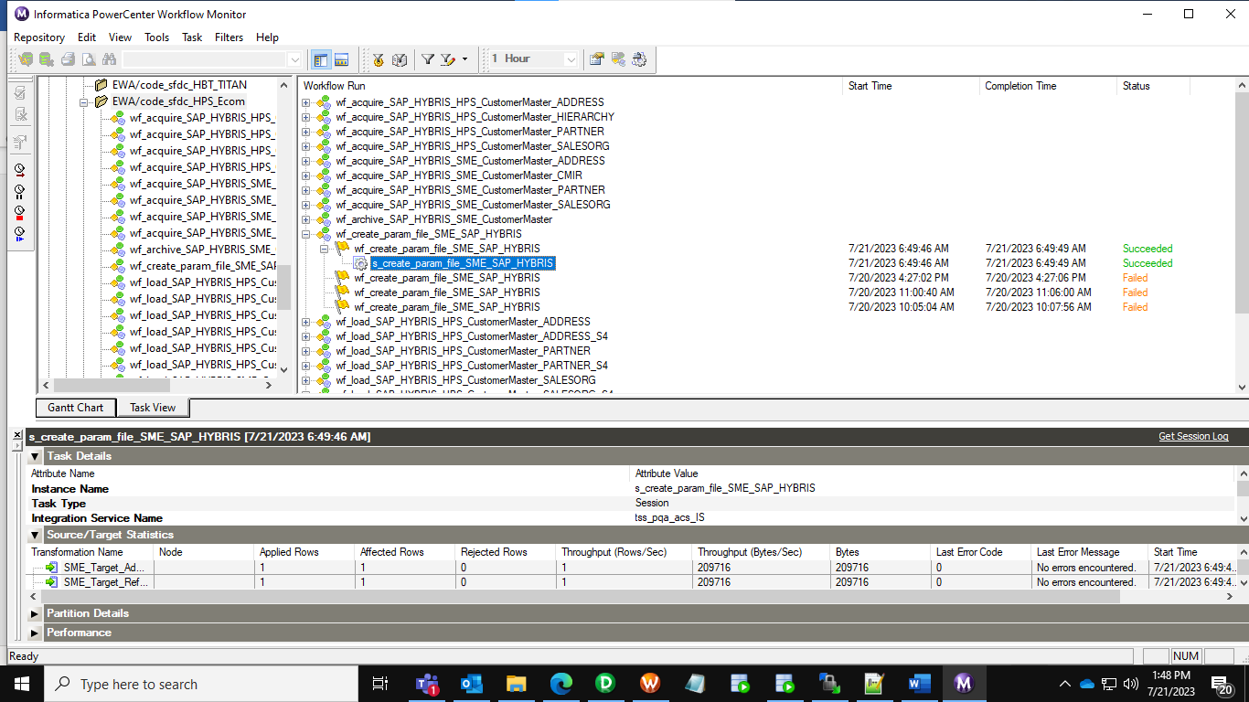 Workflow For Create Parameter File:Successful

Workflow for wf_acquire_SAP_HYBRIS_SME_CustomerMaster_ADDRESS:

Workflow For Acquire Address File:Successful

Workflow succeeded for wf_acquire_SAP_HYBRIS_SME_CustomerMaster_SALESORG

Workflow for wf_acquire_SAP_HYBRIS_SME_CustomerMaster_PARTNER

Workflow Succeded wf_acquire_SAP_HYBRIS_SME_CustomerMaster_PARTNER

Workflow for **wf_acquire_SAP_HYBRIS_SME_CustomerMaster_CMIR**

Workflow SUccded for CMir

Load Workflows:

Workflow For Address Load wf_load_SAP_HYBRIS_SME_CustomerMaster_ADDRESS

Workflow wf_load_SAP_HYBRIS_SME_CustomerMaster_ADDRESS:Succeded

Workflow for wf_load_SAP_HYBRIS_SME_CustomerMaster_SALESORG

Workflow for Load Sales org :Succeded

Workflow for Partner

Workflow for load partner :succeded

Workflow for load CMIr:

Workflow for load Cmir Succeded:

Loaded to Hybris S1 & S4 Location Files : Successful can able to see All Files:

Hybris Conformation on Output:

UAT approval mail:

